R.C.E.P. Regional Comprehensive Economic Partnership
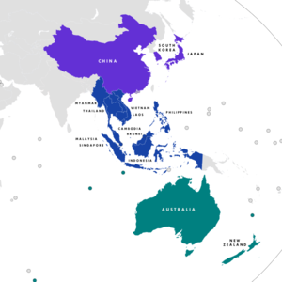
Type | Free trade agreement
Signed | 15 November 2020
Location | Hanoi, Vietnam (Virtual host)
Condition | Ratification by at least 6 of 10 ASEAN and 3 of 5 non-ASEAN signatories
Signatories | 15  - Australia  - Brunei  - Cambodia  - China  - Indonesia  - Japan  - South Korea  - Laos  - Malaysia  - Myanmar  - New Zealand  - Philippines  - Singapore  - Thailand  - Vietnam
Ratifiers | - China  - Japan  - Singapore

